Task 1
package day5_java;

import java.io.*; // ✅ Correct import statement

public class task001 {
public static void main(String args[]) {
File f1 = new File("FileName01.txt"); // ✅ Use straight double quotes

FileOutputStream outfile = null;

// ✅ Corrected character literals and enclosed in single quotes
byte Text[] = {'I', ' ', 'L', 'O', 'V', 'E', ' ', 'I', 'N', 'D', 'I', 'A'};

try {
outfile = new FileOutputStream(f1); // ✅ FileOutputStream to write bytes
outfile.write(Text); // ✅ Writing byte array to file
} catch (IOException e) {
System.out.println(e); // ✅ Error handling
System.exit(-1);
} finally {
try {
if (outfile != null)
outfile.close(); // ✅ Close the stream
} catch (IOException e) {
System.out.println("Error while closing the file: " + e);
}
}

System.out.println("Write Byte");
System.out.println("Thank You...!!!");
}
}

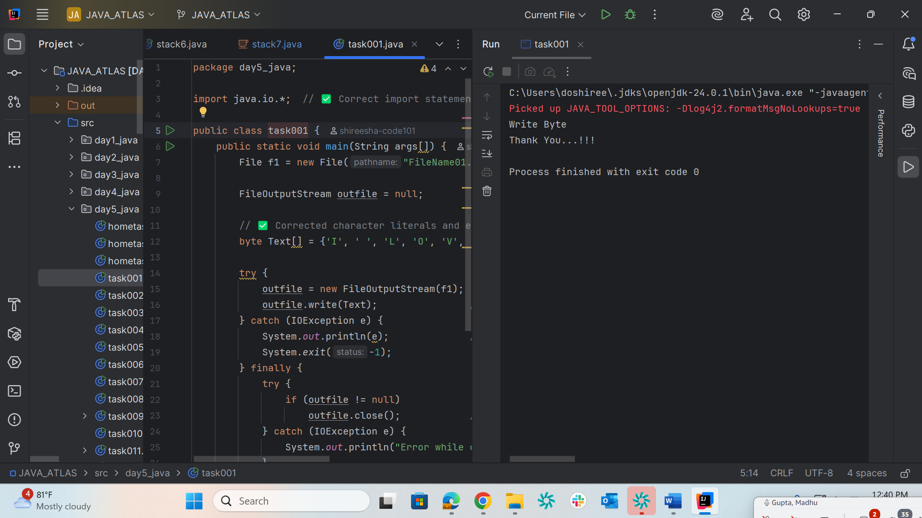

Task 2
package day5_java;

import java.io.*; // ✅ Correct import statement

public class task001 {
public static void main(String args[]) {
File f1 = new File("FileName01.txt"); // ✅ Use straight double quotes

FileOutputStream outfile = null;

// ✅ Corrected character literals and enclosed in single quotes
byte Text[] = {'I', ' ', 'L', 'O', 'V', 'E', ' ', 'I', 'N', 'D', 'I', 'A'};

try {
outfile = new FileOutputStream(f1); // ✅ FileOutputStream to write bytes
outfile.write(Text); // ✅ Writing byte array to file
} catch (IOException e) {
System.out.println(e); // ✅ Error handling
System.exit(-1);
} finally {
try {
if (outfile != null)
outfile.close(); // ✅ Close the stream
} catch (IOException e) {
System.out.println("Error while closing the file: " + e);
}
}

System.out.println("Write Byte");
System.out.println("Thank You...!!!");
}
}

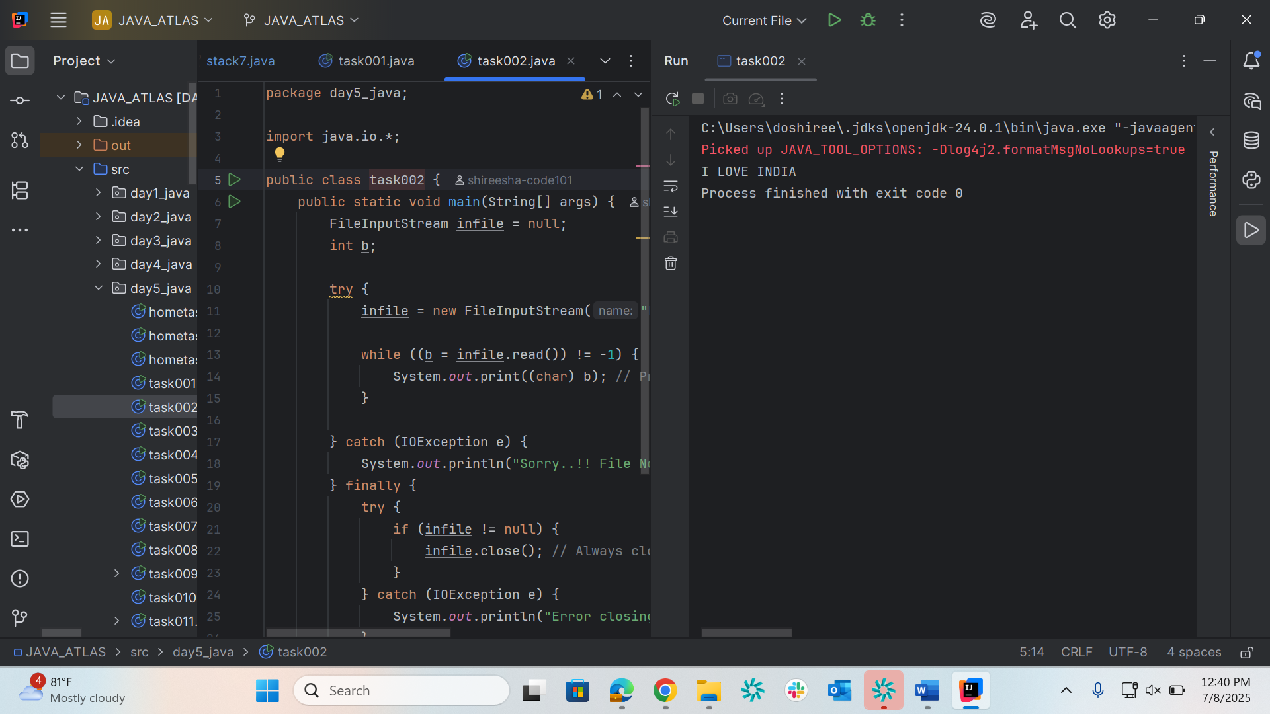

Task 3
package day5_java;

import java.io.*;
import java.util.*;

public class task003 {
public static void main(String args[]) {
FileOutputStream outfile = null;

Scanner sc = new Scanner(System.in);
System.out.print("Enter a string to write to the file: ");
String s = sc.nextLine();

byte b1[] = s.getBytes();

try {
outfile = new FileOutputStream("FileName02.txt");
outfile.write(b1);
} catch (IOException e) {
System.out.println(e);
System.exit(-1);
} finally {
try {
if (outfile != null)
outfile.close();
} catch (IOException e) {
System.out.println("Error while closing the file.");
}
}

System.out.println("Write Byte");
System.out.println("Thank You...!!!");
}
}
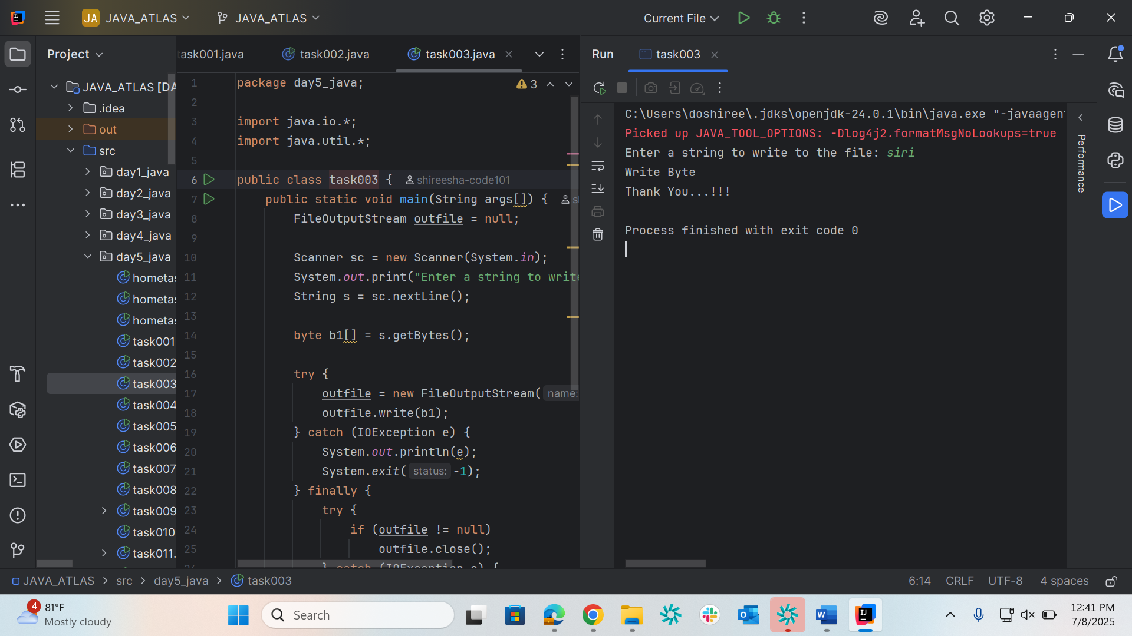

Task 4
package day5_java;

import java.io.*;

public class task004 {

public static void main(String args[]) {
File f1 = new File("FileName03.txt");
FileWriter fw = null;

try {
fw = new FileWriter(f1);
fw.write("ahmedabad\n");
fw.write("baroda\n");
} catch (FileNotFoundException e) {
System.out.println("Sorry..!! File Not Found...!!!");
} catch (IOException e) {
System.out.println(e.getMessage());
} finally {
try {
if (fw != null)
fw.close();
} catch (IOException e) {
System.out.println("Error closing the FileWriter.");
}
}

System.out.println("Write operation done!!");
}
}
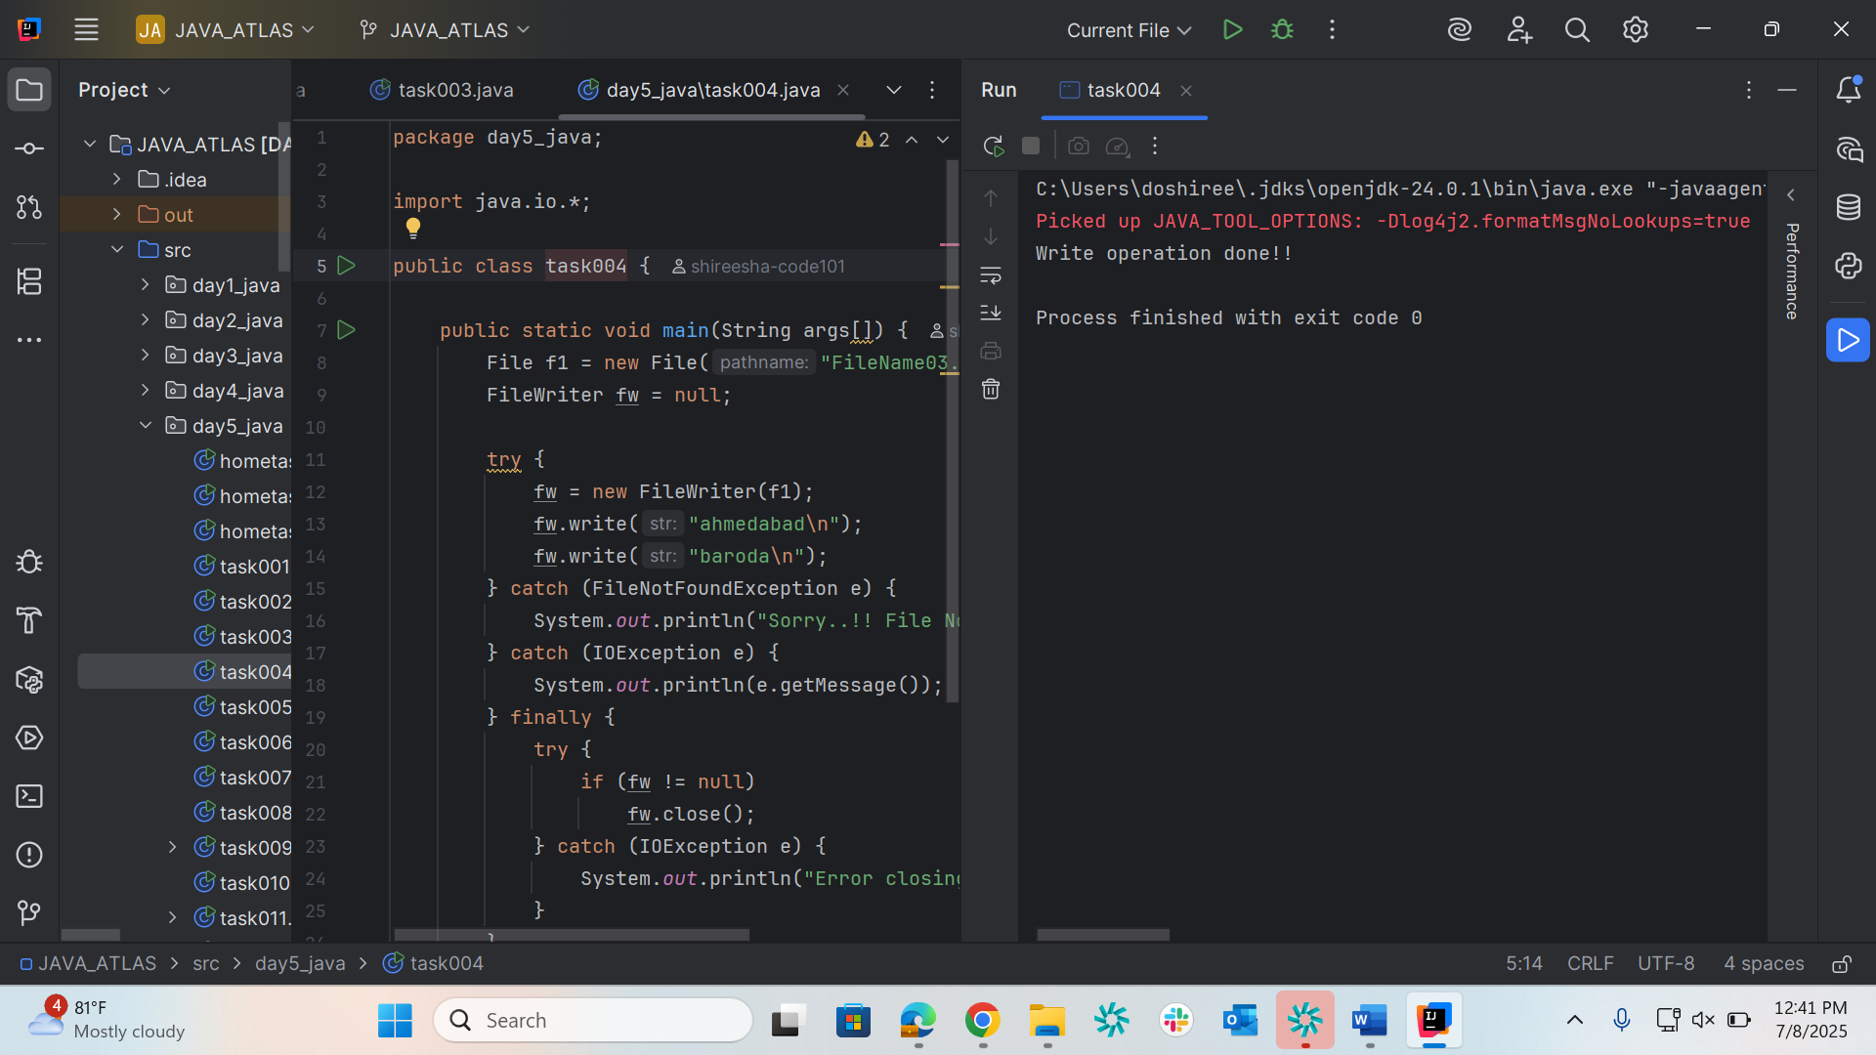

Task 5
package day5_java;

import java.io.*;

public class task005 {
public static void main(String args[]) {
FileReader fr = null;

try {
fr = new FileReader("FileName03.txt"); // Open the file
int ch;

while ((ch = fr.read()) != -1) {
System.out.print((char) ch); // Print each character
}

System.out.println("\nReading complete");
} catch (FileNotFoundException e) {
System.out.println("Sorry..!! File Not Found...!!!");
} catch (IOException e) {
System.out.println(e.getMessage());
} finally {
try {
if (fr != null)
fr.close(); // Safely close FileReader
} catch (IOException e) {
System.out.println("Error closing file.");
}
}
}
}
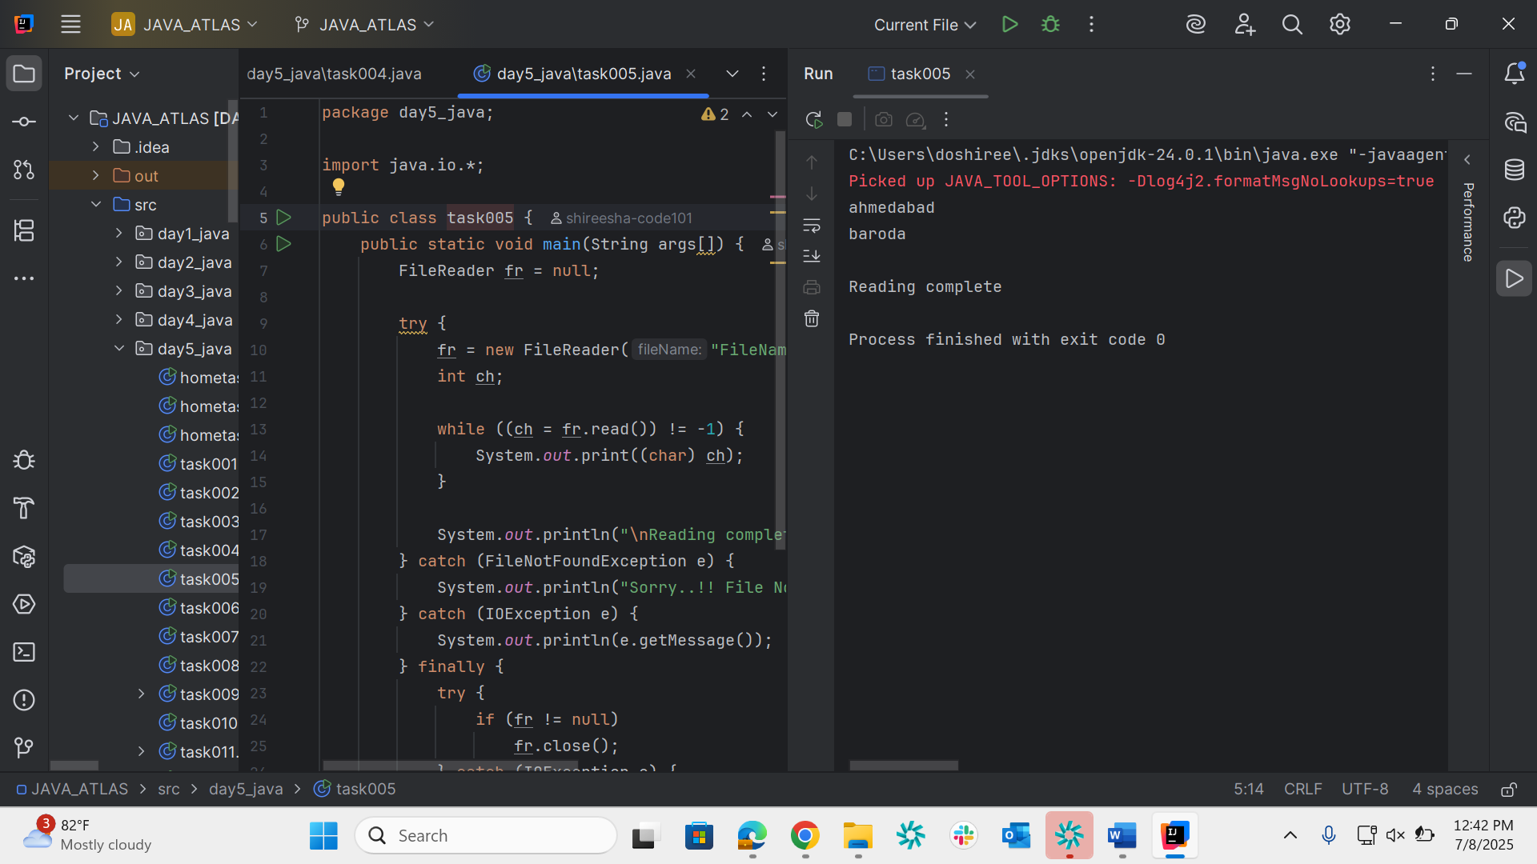

Task 6
package day5_java;

import java.io.*;

public class task006 {
public static void main(String args[]) {
FileInputStream infile = null;
FileOutputStream outfile = null;

try {
infile = new FileInputStream("NewFile01.txt");
outfile = new FileOutputStream("NewFile05.txt");

int byteread;

while ((byteread = infile.read()) != -1) {
outfile.write(byteread);
}

System.out.println("Bytes copied from NewFile01.txt to NewFile05.txt");

} catch (FileNotFoundException e) {
System.out.println("Sorry..!! File Not Found...!!!");
} catch (IOException e) {
System.out.println(e.getMessage());
} finally {
try {
if (infile != null) infile.close();
if (outfile != null) outfile.close();
} catch (IOException e) {
System.out.println("Error closing the files.");
}
}
}
}
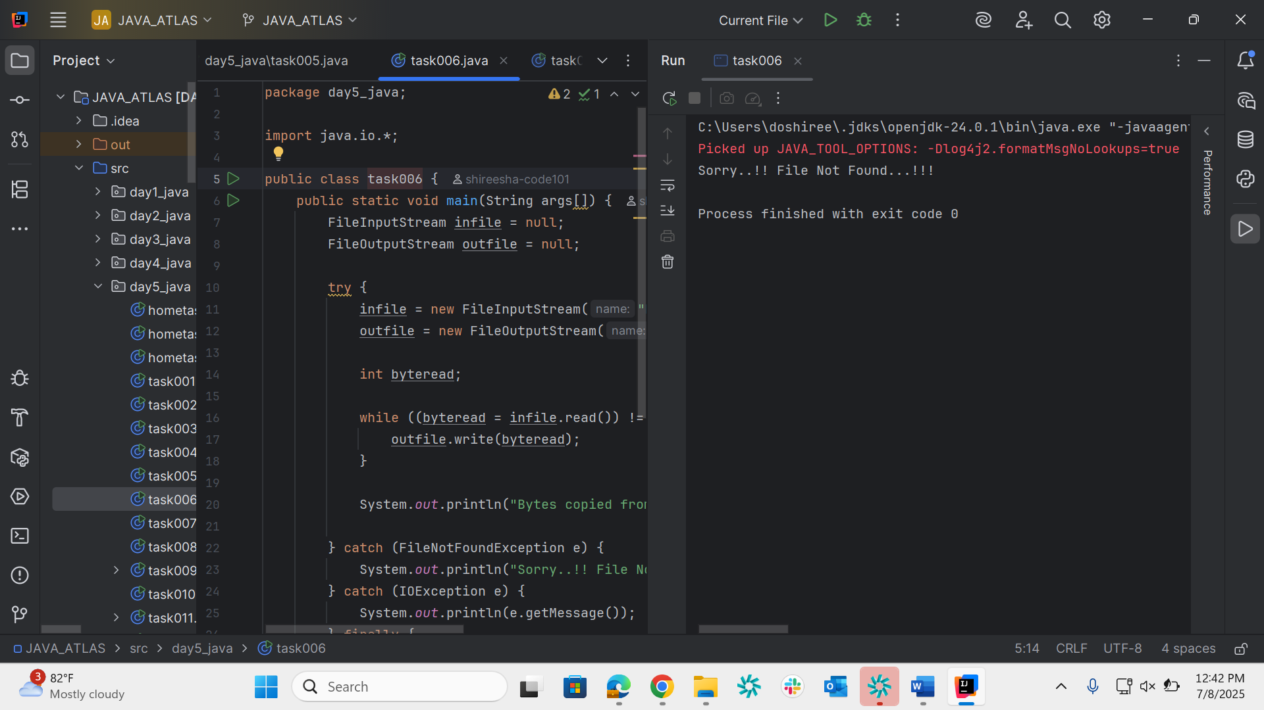

Task 7
package day5_java;

import java.io.*;

public class task007 {
public static void main(String[] args) {
FileInputStream file1 = null;
FileInputStream file2 = null;
SequenceInputStream file3 = null;
BufferedInputStream br1 = null;
BufferedOutputStream br2 = null;

try {
file1 = new FileInputStream("NewFile01.txt");
file2 = new FileInputStream("NewFile02.txt");

file3 = new SequenceInputStream(file1, file2);

br1 = new BufferedInputStream(file3);
br2 = new BufferedOutputStream(new FileOutputStream("MergedFile.txt")); // ✅ Output to new file

int ch;
while ((ch = br1.read()) != -1) {
br2.write(ch);
}

System.out.println("Merged both files successfully into MergedFile.txt");

} catch (IOException e) {
System.out.println("Sorry..!! File Not Found or IO Error...!!!");
} finally {
try {
if (br1 != null) br1.close();
if (br2 != null) br2.close();
if (file1 != null) file1.close();
if (file2 != null) file2.close();
} catch (IOException e) {
System.out.println("Error closing resources.");
}
}
}
}
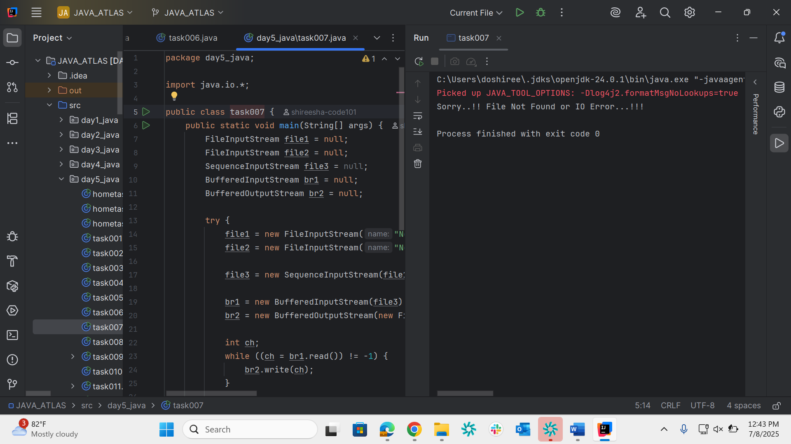
Task 8
package day5_java;

import java.io.*;

public class task008 {
public static void main(String args[]) {
if (args.length < 2) {
System.out.println("Usage: java FileRenameDemo <old_filename> <new_filename>");
return;
}

File f1 = new File(args[0]); // Old file
File f2 = new File(args[1]); // New file name

if (!f1.exists()) {
System.out.println("The file " + args[0] + " does not exist.");
return;
}

if (f1.renameTo(f2)) {
System.out.println("Renamed file " + f1.getName() + " to " + f2.getName() + " successfully.");
} else {
System.out.println("Failed to rename the file.");
}
}
}
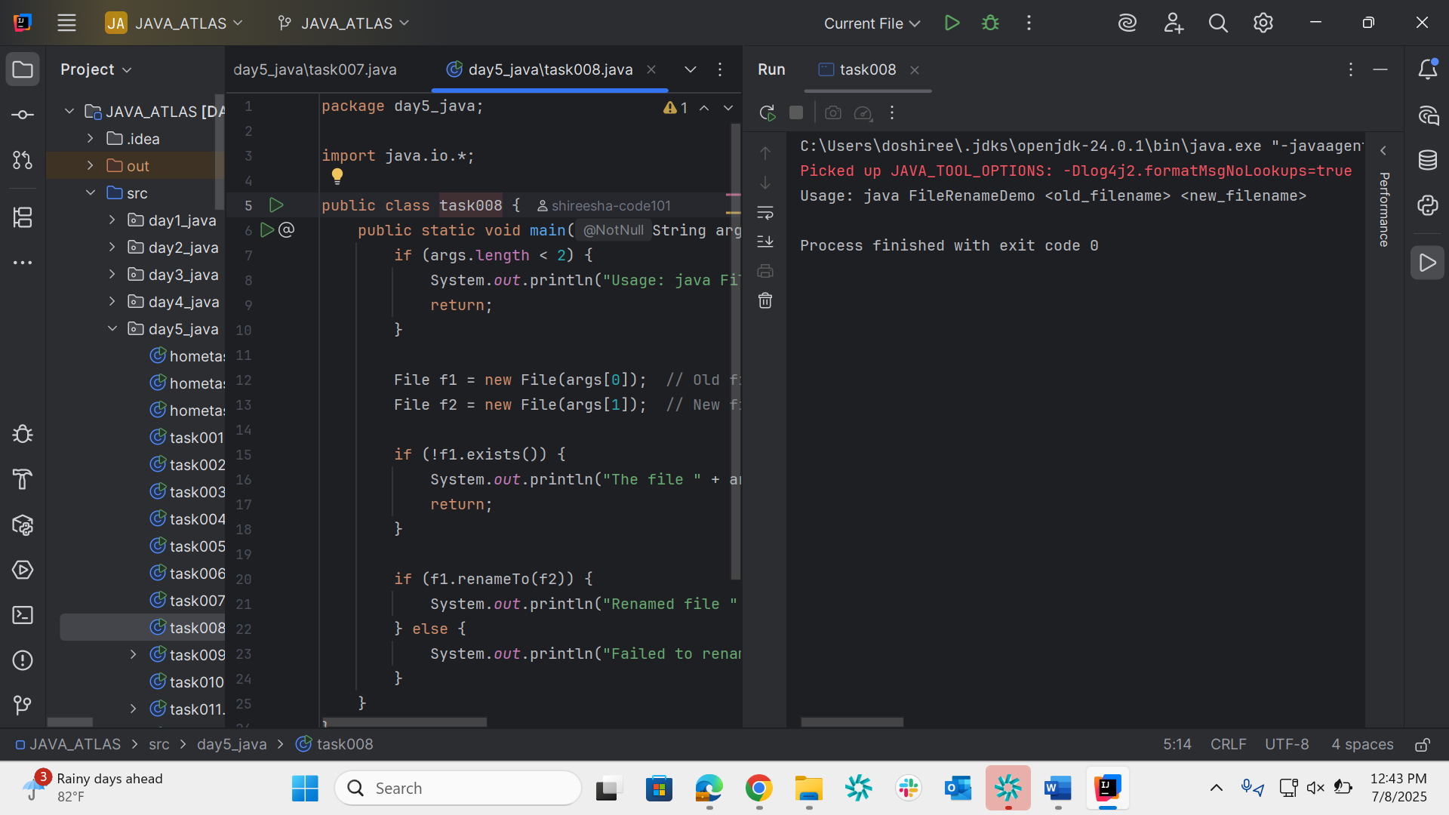

Task 9
package day5_java;

@FunctionalInterface
interface MyInterface {
double getPiValue();
}

public class task009 {
public static void main(String[] args) {
MyInterface ref;
ref = () -> 3.1415;
System.out.println("Value of Pi = " + ref.getPiValue());
}
}
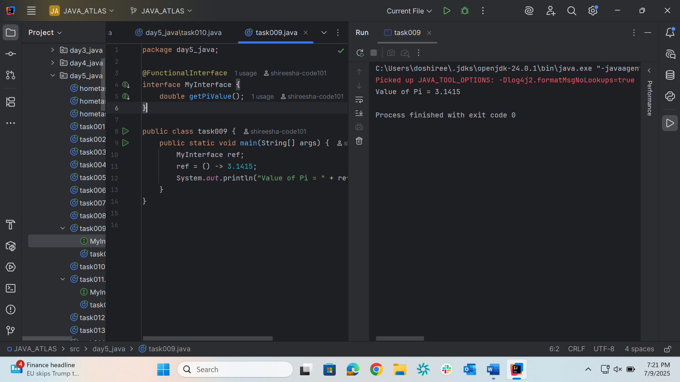
Task 10
package day5_java;

import java.util.Scanner;

public class task010 {
public static void main(String[] args) {
Scanner sc = new Scanner(System.in);
System.out.print("Enter a string: ");
String original = sc.nextLine();

String reversed = "";

for (int i = original.length() - 1; i >= 0; i--) {
reversed += original.charAt(i);
}

System.out.println("Reversed string: " + reversed);
}
}

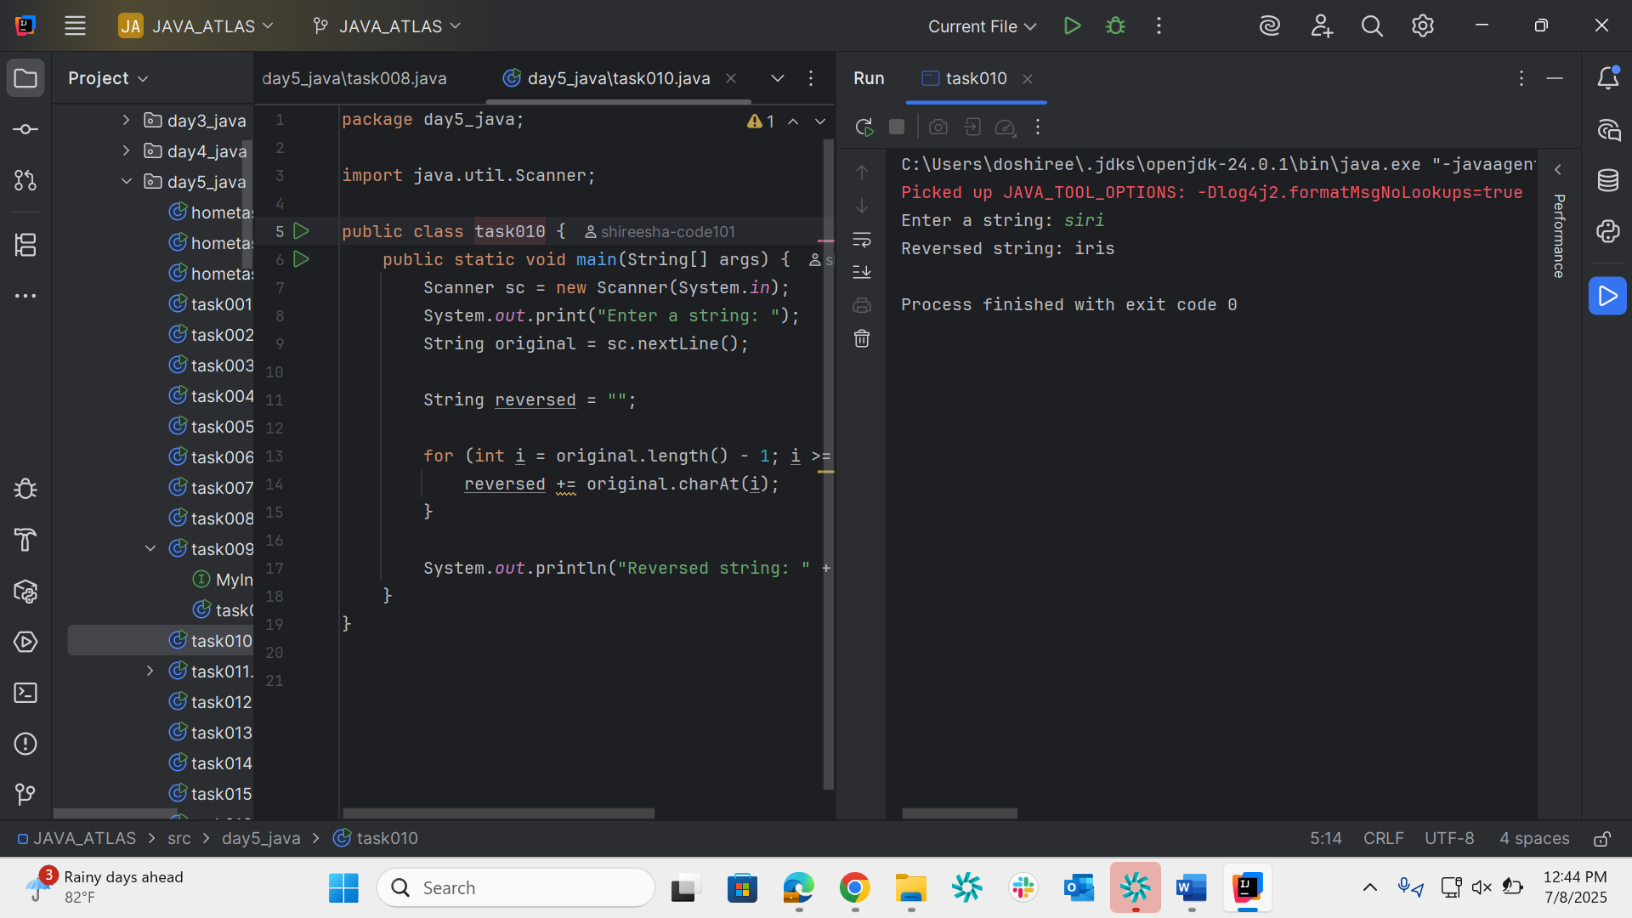
Task 11
package day5_java;

@FunctionalInterface
interface MyInterface1 {
String reverse(String n);
}

public class task011{
public static void main(String[] args) {
MyInterface1 ref = (str) -> {
String result = "";
for (int i = str.length() - 1; i >= 0; i--)
result += str.charAt(i);
return result;
};

System.out.println("Lambda reversed = " + ref.reverse("Lambda"));
}
}
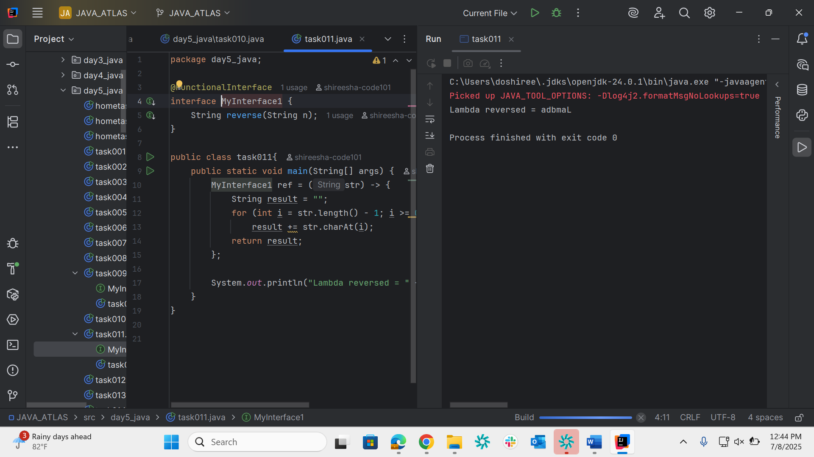

Task 12
package day5_java;

import java.util.ArrayList;

public class task012 {
public static void main(String[] args) {
ArrayList<String> friends = new ArrayList<>();

friends.add("Alice");
friends.add("Bob");
friends.add("Charlie");
friends.add("David");
friends.add("Emma");

System.out.println("My Friends:");
for (String name : friends) {
System.out.println(name);
}
}
}
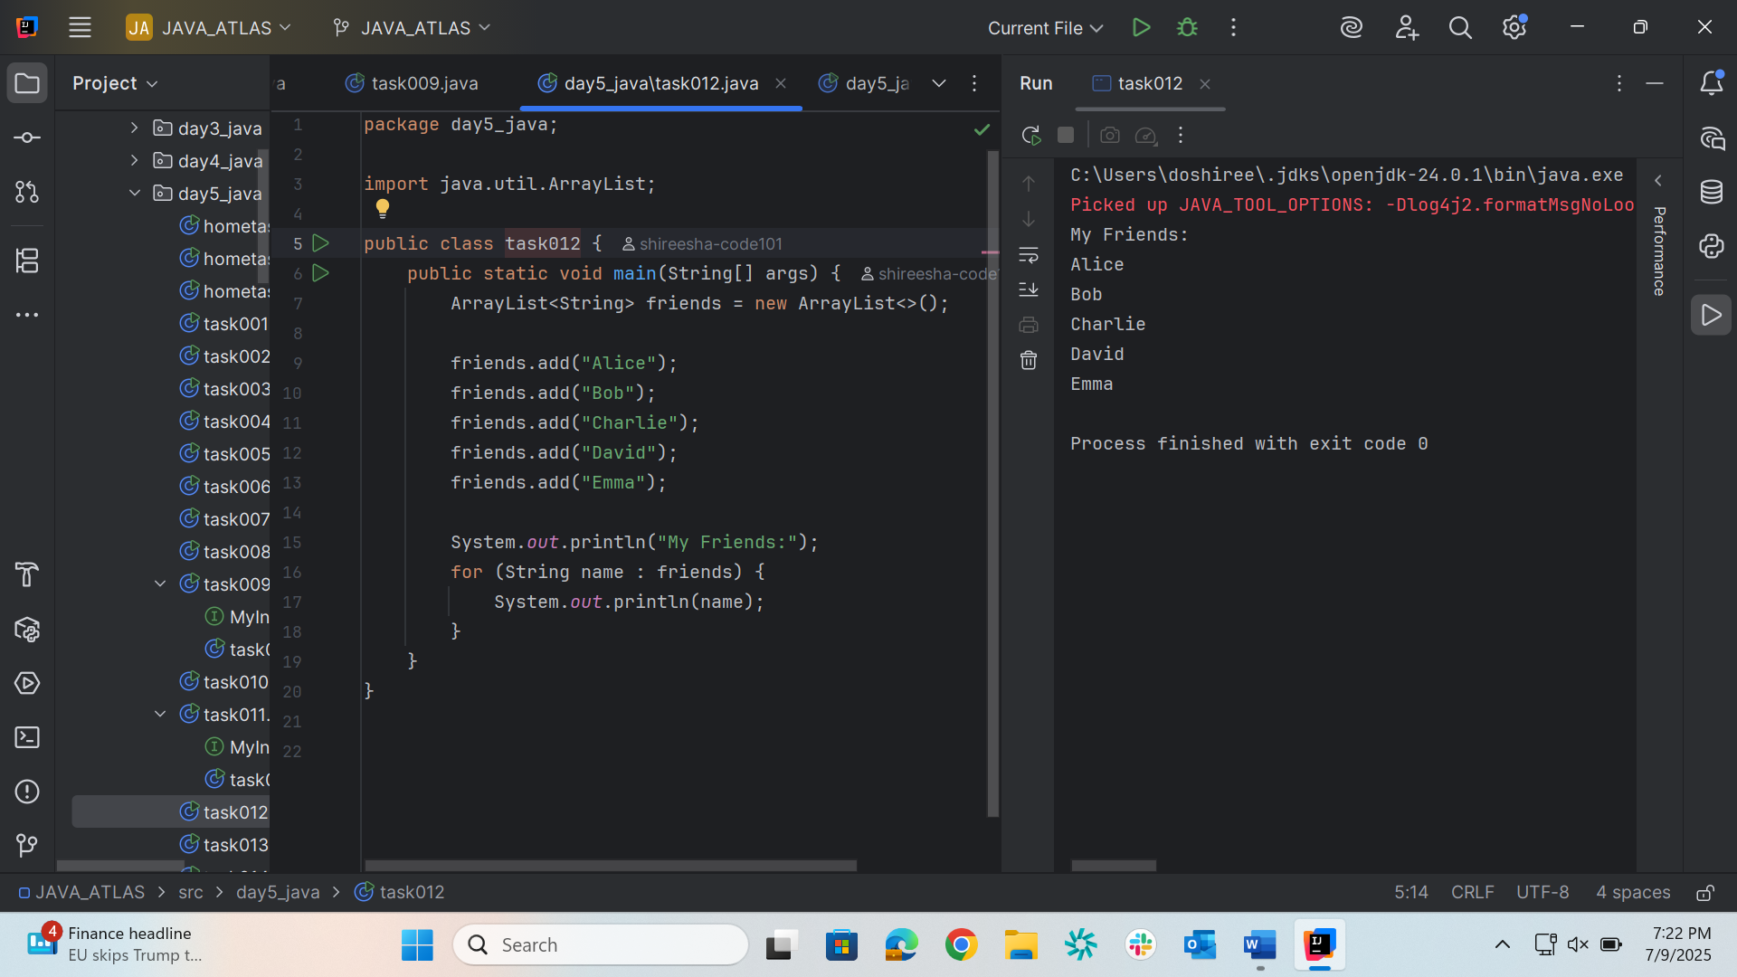

Task 13
package day5_java;

import java.util.*;

public class task013 {
static List<String> fullName = new ArrayList<>();

public static void main(String[] args) {
fullName.add("Alice Johnson");
fullName.add("Bob Smith");
fullName.add("Charlie Brown");
fullName.add("David Miller");
fullName.add("Emma Watson");

System.out.println("Friends' Full Names:");
for (String name : fullName) {
System.out.println(name);
}
}
}
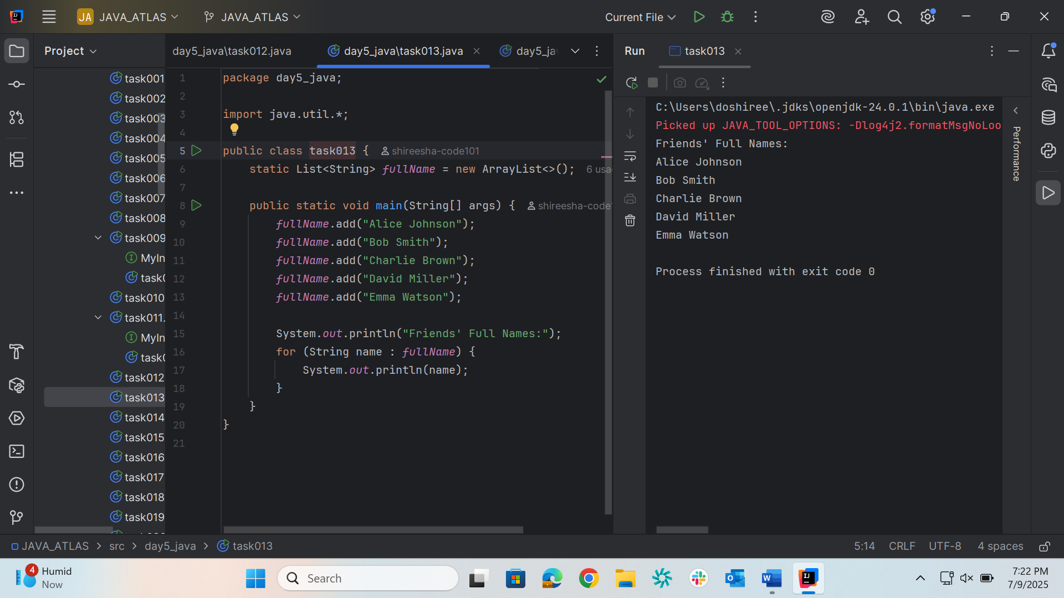

Task 14
package day5_java;

import java.util.ArrayList;
import java.util.List;

public class task014 {

public static List<String> getPlaces() {
List<String> places = new ArrayList<>();
places.add("Nepal, Kathmandu");
places.add("Nepal, Pokhara");
places.add("India, Delhi");
places.add("USA, New York");
places.add("Africa, Nigeria");
return places;
}

public static void main(String[] args) {
List<String> myPlaces = getPlaces();
System.out.println("Places from Nepal:");

myPlaces.stream()
.filter(p -> p.startsWith("Nepal"))
.map(String::toUpperCase)
.sorted()
.forEach(System.out::println);
}
}
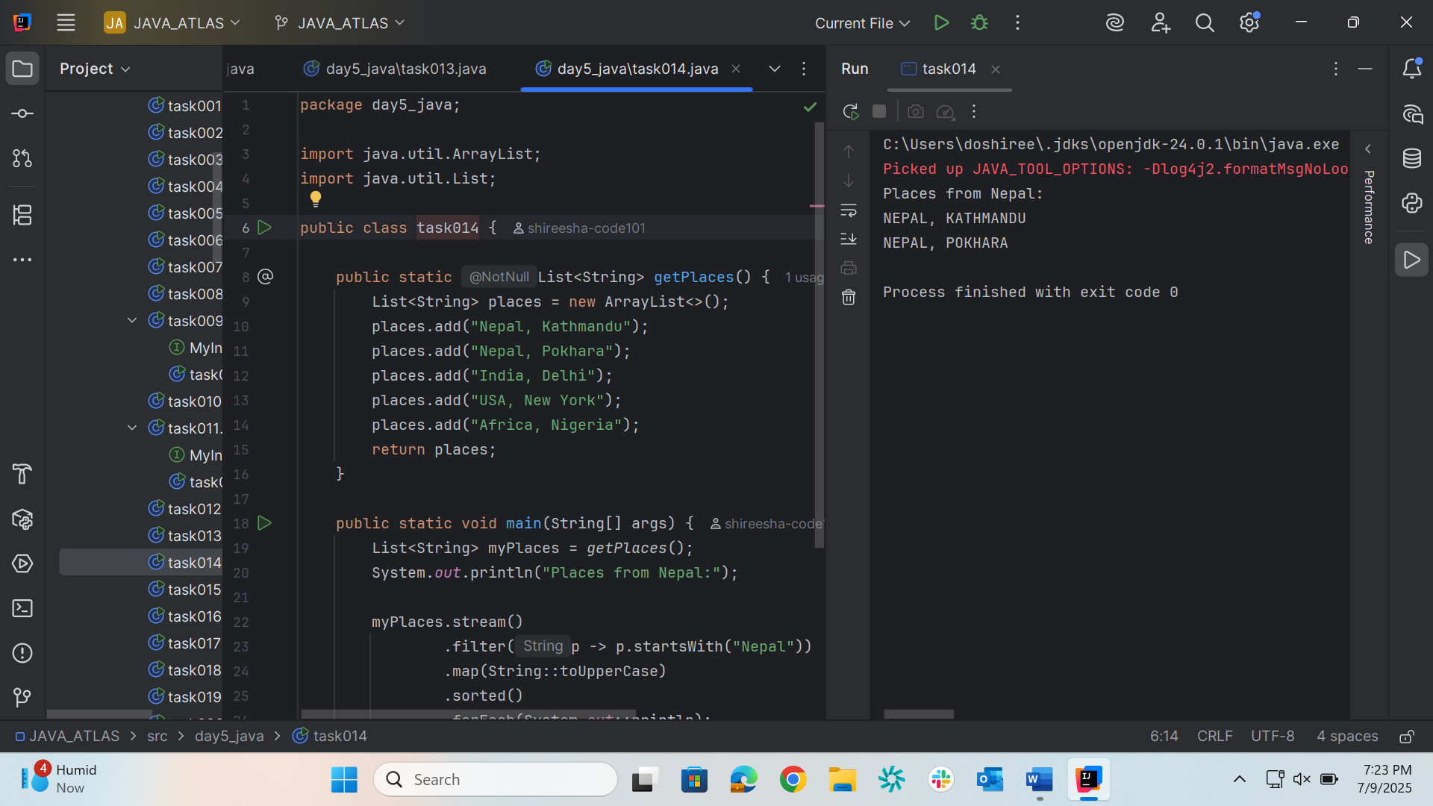

Task 15
package day5_java;

import java.util.*;
import java.util.stream.Collectors;

public class task015 {
public static void main(String[] args) {
List<Integer> numbers = Arrays.asList(2, 4, 6, 8, 10);

List<Integer> squareOfNums = numbers.stream()
.map(num -> num * num)
.collect(Collectors.toList());

System.out.println("Original numbers: " + numbers);
System.out.println("Squares: " + squareOfNums);
}
}
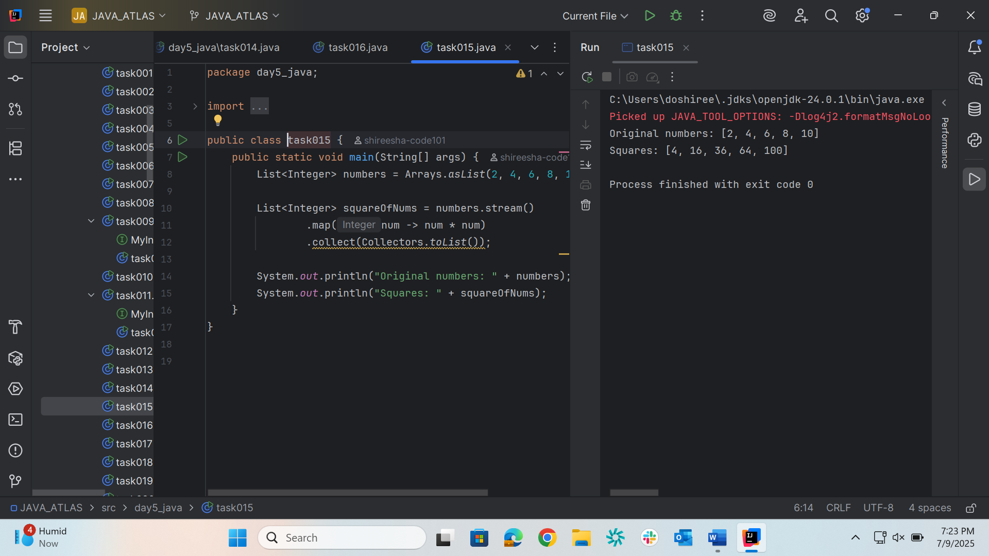
Task 16
package day5_java;

import java.util.*;
import java.util.stream.Collectors;

public class task016 {
public static void main(String[] args) {
List<Integer> numbers = Arrays.asList(11, 22, 33, 44, 55);

List<Integer> oddNumbers = numbers.stream()
.filter(num -> num % 2 != 0)
.collect(Collectors.toList());

System.out.println("Original numbers: " + numbers);
System.out.println("Odd numbers: " + oddNumbers);
}
}
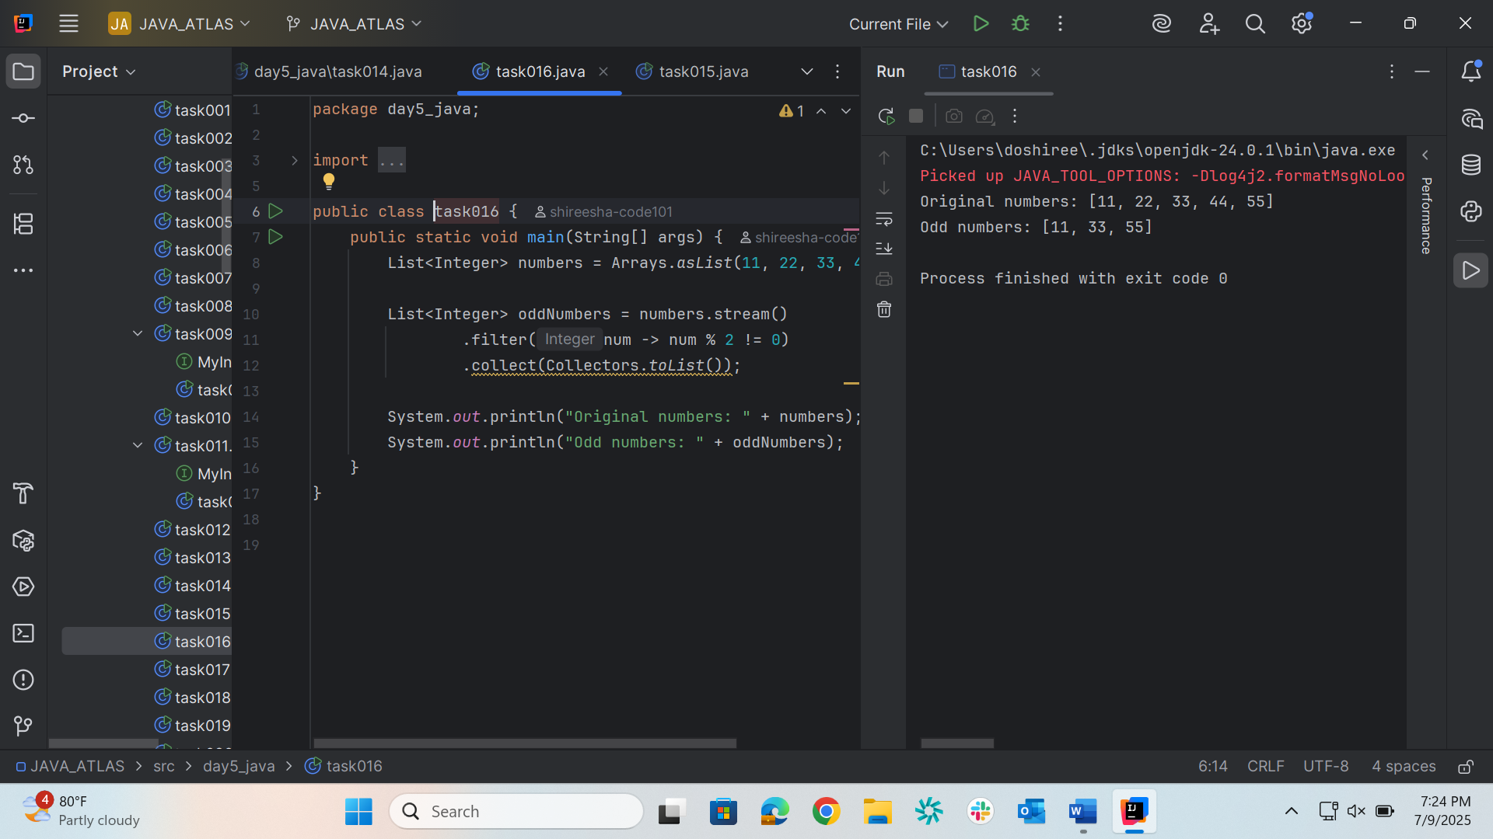

Task 17
package day5_java;

import java.util.*;
import java.util.stream.Collectors;

public class task017
{
public static void main(String[] args) {
List<Integer> numbers = Arrays.asList(10, 20, 10, 30, 20, 40, 50, 30);

List<Integer> removeDups = numbers.stream()
.distinct()
.collect(Collectors.toList());

System.out.println("Original list: " + numbers);
System.out.println("List after removing duplicates: " + removeDups);
}
}
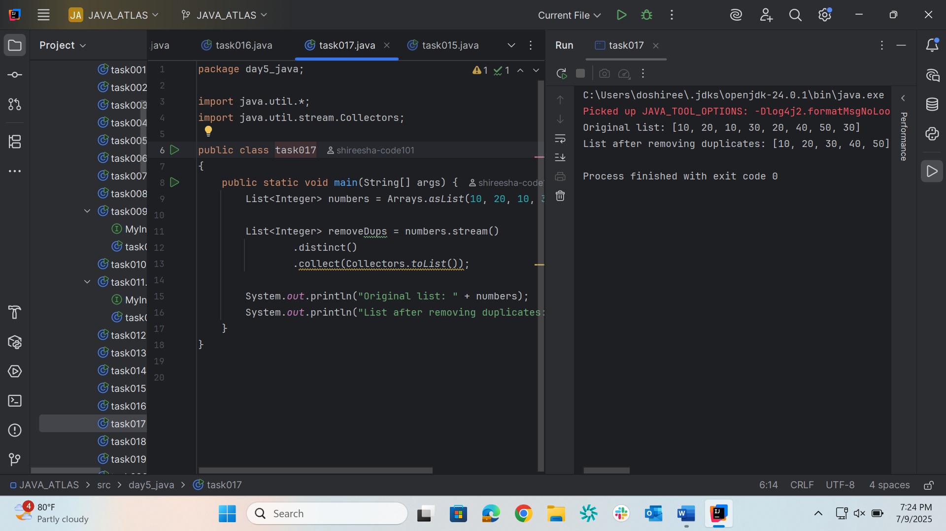
Task 18
package day5_java;

import java.util.*;
import java.util.stream.Collectors;

public class task017
{
public static void main(String[] args) {
List<Integer> numbers = Arrays.asList(10, 20, 10, 30, 20, 40, 50, 30);

List<Integer> removeDups = numbers.stream()
.distinct()
.collect(Collectors.toList());

System.out.println("Original list: " + numbers);
System.out.println("List after removing duplicates: " + removeDups);
}
}
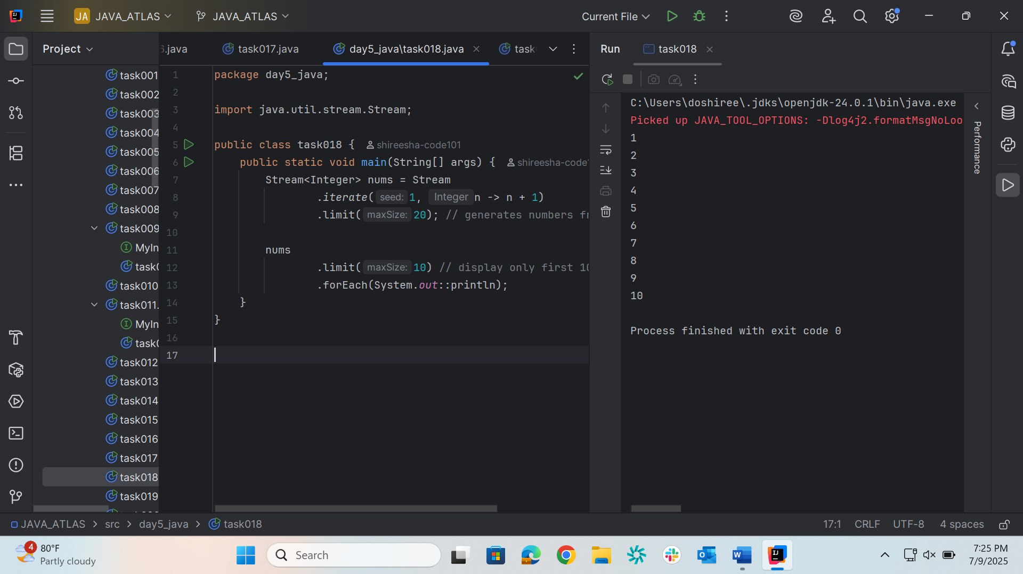

Task 19
package day5_java;

import java.util.stream.Stream;

public class task019 {
public static void main(String[] args) {
Stream<Integer> nums = Stream
.iterate(1, n -> n + 1)
.limit(20);

Stream<Integer> skipNums = nums.skip(15);

skipNums.forEach(System.out::println);
}
}

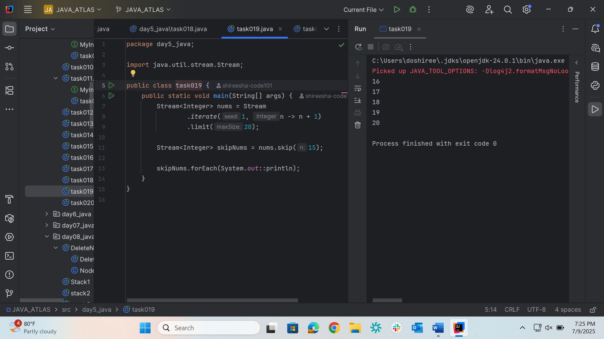

Task 20
package day5_java;

import java.util.Arrays;
import java.util.List;
import java.util.Optional;

public class task020 {
public static void main(String[] args) {

List<Integer> numbers = Arrays.asList(1, 2, 3, 4, 5);

Optional<Integer> sum = numbers.stream().reduce((x, y) -> x + y);
System.out.println("Sum of all elements: " + sum.orElse(0));

Optional<Integer> max = numbers.stream().reduce(Integer::max);
System.out.println("Maximum element: " + max.orElse(0));

List<String> strings = Arrays.asList("Hello", " ", "world", "!");
Optional<String> concatenatedString = strings.stream().reduce((x, y) -> x + y);
System.out.println("Concatenated string: " + concatenatedString.orElse(""));
}
}

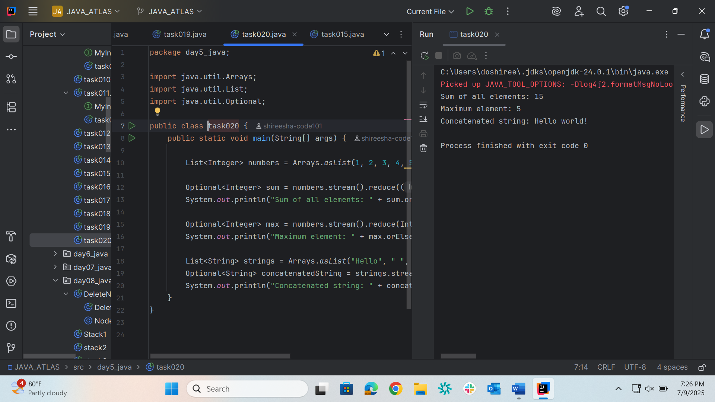
Home task 1
package day5_java;

import java.io.BufferedReader;
import java.io.FileReader;
import java.io.IOException;

public class hometask1 {
public static void main(String[] args) {
try (BufferedReader br = new BufferedReader(new FileReader("largefile.txt"))) {
String line;
while ((line = br.readLine()) != null) {
System.out.println(line);
}
} catch (IOException e) {
e.printStackTrace();
}
}
}

Home task 2
package day5_java;

import java.io.FileReader;
import java.io.IOException;

public class hometask2 {
public static void main(String[] args) {
try (FileReader fr = new FileReader("largefile.txt")) {
int ch;
while ((ch = fr.read()) != -1) {
System.out.print((char) ch);
}
} catch (IOException e) {
e.printStackTrace();
}
}
}

Home task 3
package day5_java;

import java.io. BufferedWriter;
import java.io.FileWriter;
import java.io.IOException;

public class hometask3 {
public static void main(String[] args) {
String filePath = "example.txt";
String content = "Hello, World!\nThis is a BufferedWriter example.";
// Initialize BufferedWriter with a FileWriter
try (BufferedWriter writer = new BufferedWriter(new FileWriter(filePath))) {
// Write content to the file
writer.write(content);
System.out.println("Content written to file.");
} catch (IOException e) {
System.err.println("An error occurred: " + e.getMessage());
}
}
}

